**18 March 2015**

**Volume 25, Issue 3**

The RACCeteer

Monthly Newsletter of the Rappahannock Area Coin Club

American Numismatic Association (ANA) Member # C-1160109

**March Meeting – Door Prize and 50/50**

Next Meeting:

19 March 2015

**7:00 PM**

SHONEY’S

# Executive Board (EB) Meeting

The EB met 11 March at Paradise Diner on route 17 in Falmouth. BTW...we are considering moving our regular meetings to this location. This will also be discussed at the March meeting. Additional items discussed included:

* RACC Membership Medal
  + We received an example from Penny Press of the medal as currently designed
  + The EB agreed that the current design is unacceptable due to bleed through of the design elements of the Kennedy half
  + Other options were discussed and will be presented to the membership at the March meeting.
    - The most promising was to encase a 1/2 oz silver blank struck with the previously agreed upon design elements but this adds $8.75 per medal
  + So far we've expended $500.00 for die production.
  + Additional costs are unchanged per medal. They are; $2.50 for design strike, $1.00 for engraving members number and $8.00 for gold plating of the racketeer design element on the reverse.

# Meeting Summary - February 2015

The President called the meeting to order 7PM Thursday, FEB 20th with 17 members present. The Treasurer was unable to attend therefore no report was presented. Ernie Swauger was previously a member and returned to rejoin the club…welcome back Ernie! January meeting minutes were unanimously approved.

**Old Business:**

* J. Hepler provided an update of the RACC Membership medal and expects a sample soon.
* J. Hepler again encouraged our youth members to create an exhibit for the VNA show in September 2015.

**New Business:**

* There was no new business discussed.

**Program:**

* Jack Hepler gave a presentation titled "One Century, Three Russias".

**Conclusion:**

The meeting adjourned at 8:07pm.

***Inside this issue:***

Meeting Summary 1

EB Meeting 1

Numismatist Index 2

Upcoming Club Events 2

RACC Birthdays 2

VNA Coin Show Info 2

Non-Cents! 2

Membership Medal 3

***RACC Officers:***

President

Jack Hepler -(540) 972-9678

heplerj@juno.com

Vice President

Billy Hoovler –(540) 785-7188

rubberhook1@aol.com

Secretary

Jack Bell – (540) 498-8194

jack.bell1@navy.mil

Treasurer

Sam Ghormley –

(540) 907-9394

spotcat_91@yahoo.com

View 24/7 Gold and Silver SPOT Prices from the RACC website.

We’re on the Web!

*See us at:*

[*www.racceteer.com*](http://www.racceteer.com)

# Executive Board (EB) Meeting (Cont.)

* The EB approved and propose authorization of Lifetime Membership at a cost of $120.00 per member.
  + Additional family memberships would cost $6.00 per person, per year.
  + Family members qualify for Lifetime membership at a cost of $120.00 each.
* Family Membership Change- annual memberships remain at $12.00 each per year but family members can be added for $6.00 each.
  + This is a change from current charges: $12.00 for the main membership and one $6.00 charge for all other family members regardless of the number.
  + This will require a bylaws change.
* RACC officer elections will take place during the May 2015 meeting.
  + Previously approved by the membership at the May 2014 meeting, officers will now serve two year terms.
    - Starting with the 2015/2016 term; elections for Vice President/Secretary will take place first followed by President/Treasurer the following year.
    - Therefore, elections for the positions of Secretary and Vice President will take place during the May 2014 meeting.
    - Nominations will be accepted during the April and May 2014 meetings and all members are eligible. Please consider stepping up to fill one of these important positions.
* Two spaces have been reserved for the 2015 Fredericksburg Heritage Festival that will take place July 4th. We need member volunteers to man our booth. This has proven to be an excellent event for community service, help to raise awareness of numismatics and recruitment of new members. Please consider volunteering to assist with this event.

*Source – http://www.pbs.org/civilwar/war/facts.html*

# The Numismatist Index- March 2015

* **EXONUMIA:** "Penny Potpourri"
* **MEDALS:** "Die Trials: Insights into the U.S. Mint's Medal Production"
* **ANCIENTS:** "The World's First Dated Coins"

# Upcoming Club Events

* Club member presentations will be updated and included in the April 2015 newsletter.

# Keep in mind...

* One of the main purposes of our club is to educate. As such, the Vice-president will be asking members to sign-up as presenters during our 2015 meetings. Topics can include information about your collecting interests or some other relevant topic. Additionally, members are asked to consider arranging guest speakers that might be able to present topics of interest during meetings. Please let B. Hoovler know if you can fill an opening or you have an outside presenter that may be of interest to the club.

# NON-CENTS! Lawyers and Money!!!

Q: Santa Claus, the tooth fairy, an honest lawyer and an old drunk are walking down the street together when they simultaneously spot a hundred dollar bill. Who gets it?

A: The old drunk, of course; the other three are mythological creatures

After drafting a will for an elderly client, the lawyer announced a fee of $100. The client gave the lawyer a $100 bill. After the client left, the lawyer saw that the client had in fact paid $200, as two of the client's $100 bills had stuck together. Looking at the $100 overpayment, an ethical question arose in the lawyer's mind: "Do I tell my partner?"

A housewife, an accountant and a lawyer were asked "How much is 2+ 2?" The housewife replies: "Four!" The accountant says: "I think it's either 3 or 4. Let me run those figures through my spreadsheet one more time." The lawyer pulls the drapes, dims the lights and asks in a hushed voice, "How much do you want it to be?"

# March RACC Birthdays!

* Russ Pepper-25th
* Jerry Davis-29th
* Randolph Grimes-30th
* **☺** Let the secretary know if you'd like to see your name listed when your birthday comes around. We'd love to wish you a happy one! **Happy Birthday to All!!!**

# VNA Coin Club Show Info

***Shenandoah Valley Club Coin & Stamp Show*** APR 2-4, 2015, Thursdays 2:00pm-7:00pm, Friday 9:00am-5:00pm, Saturday 9:00am-4:00pm. Weyers Cave, VA, Contact: Melissa Smith PH: 540-363-7777, visit the web: <http://svccshow.info> or e-mail: svccshow@gmail.com.

***Warrenton Stamp & Coin Club Annual Show*** APR 25, 2015, 9:00am-3:00pm, Highland School, 597 Broadview Ave., Warrenton, VA, Contact Tony Tripi, PH: 540-347-2567.

***Richmond Annual Spring Coin & Currency Show*** MAY 1-3, 2015, Friday & Saturday 10:00am-6:00pm, Sunday 10:00am-3:00pm, Clarion Richmond Central, 3207 N. Blvd, Richmond, VA. E-mail: woscott1@verizon.net.

***Salem Coin Club Show*** AUG-15=16, 2015, Saturday 9:30am-5:30pm, Sunday 9:30am-3:30pm, American Legion Hall, 710 Apperson Dr., Salem, VA. Contact Will Camp, P.O. Box 283, Fishersville, VA 22939.

***Virginia Numismatic Association (VNA) 57th Convention & Coin Show*** SEP 25-27, Fredericksburg Expo & Conference Center, 2371 Carl D. Silver PKWY, Fredericksburg, VA 22401. Contract John Cunningham, PH: 703-303-0783 or e-mail: cunningham314@verizon.net or visit the VNA website; www.vnaonline.org

**RACC MEMBERSHIP MEDAL**

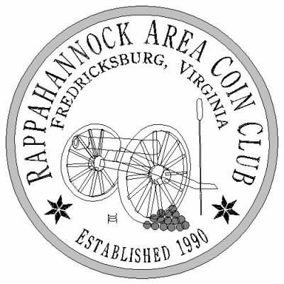

**Obverse**

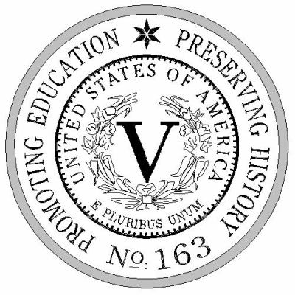

**Reverse**